Pharmacovigilance internship
Task 2 ADR Reporting & Documentation
Complete a structured ADR reporting form based on a given case scenario. This task simulates real-world pharmacovigilance reporting systems used in healthcare and pharmaceutical industries.
CASE STUDY
6 yr old male child (named EA) with body weight 17 kg, admitted with history of fever, swollen neck, abdominal pain joint pain and reddened tongue and diagnosed as Kawasaki disease. His lab investigation data:
Hb: 10.0 gm% ,TC: 10900/c.mm Platelets: 2.87 lakhs/c.mm
PCV: 33.5% MCV: 78.8 fl.
Treatment was started on 23rd June 2023 with Inj.Intravenous Immunoglobulin (IVIG) (Mfg by: Reliance life sciences, batch no: ID05G21020, Mfg date: Sep 2022, Expiry date: Aug 2025)
Dose - 2g/kg/day IV OD.
The patient developed itching all over the body and rashes or. 23rd June 2023 following the injection. Drug was withdrawn
24th June 2023 and the reaction was managed with Inj .Chlopheniramine IV and Inj.Dexamethasone IV .
He recovered from the reaction on 24th June 2023.
The suspected drug was again given to the patient on 27th June 2023 and itching all over the body recurred the same day.
The drug was stopped and appropriate treatment given.

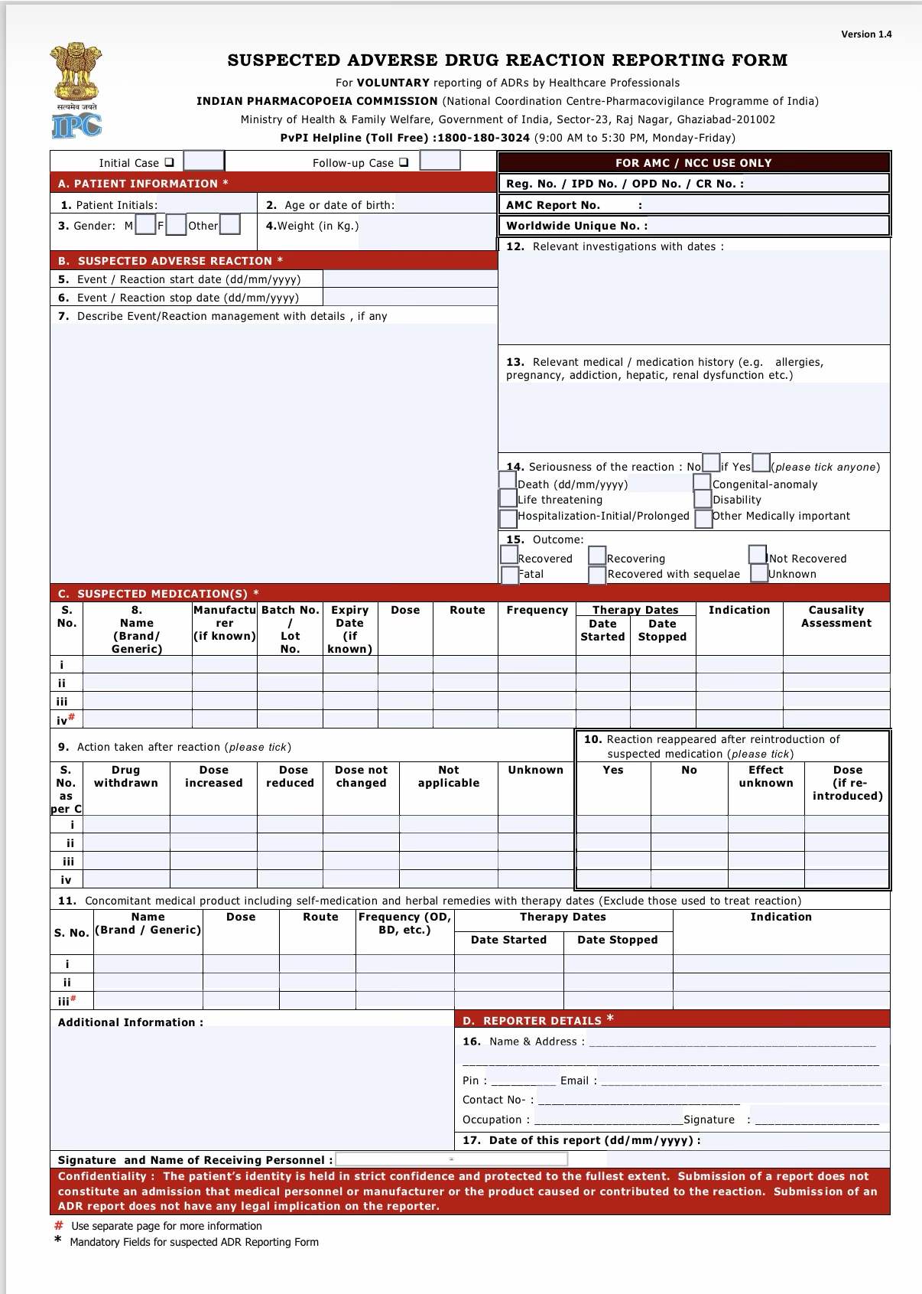
Reporting form
Initial Case
A) PATIENT INFORMATION
1. Patient Initials | EA
2. Age / Date of birth | 6 years
3. Gender | Male ✓
4. Weight | 17 kg

B) SUSPECTED ADVERSE REACTION

5. Event / Reaction start date 23/06/2023

6. Event / Reaction stop date 24/06/2023

7. Describe Event/Reaction management with details

Patient developed itching and rashes following Injection Intravenous Immunoglobulin( IVIG) administration. Drug was withdrawn on 24/06/2023. The reaction was managed with IV chlorpheniramine and IV dexamethasone. The patient recovered on 24/06/2023.

12. Relevant investigations with dates
Lab investigations
Hb: 10.0 g/dL; Total count:10,900/c.mm; Platelets: 2.87 lakhs/c.mm; PCV: 33.5%; MCV: 78.8 fL. Date of investigations: Not reported

13. Relevant medical / medication history
Admitted with history of fever, swollen neck, abdominal pain, joint pain, reddened tongue diagnosed with Kawasaki disease.

14. Seriousness of the reaction – NO

15. Outcome -Recovered

C. SUSPECTED MEDICATION(S)
Field | Entry
Name (Brand/Generic) | Intravenous Immunoglobulin (IVIG)
Manufacturer | Reliance Life Sciences
Batch No. | ID05G21020
Expiry date | August 2025
Dose | 2 g/kg/day
Route | IV
Frequency | OD
Therapy Date Started | 23/06/2023
Date Stopped | 24/06/2023
Indication | Kawasaki disease
Causality Assessment | Not reported in case scenario

9. Action taken after reaction - Drug withdrawn

10. Reaction reappeared after reintroduction? – Yes

11 Concomitant medication
Not reported in the case scenario

12 Additional Information
Patient developed itching and rashes following IVIG administration on 23/06/2023. IVIG was withdrawn on 24/06/2023 and the reaction was treated with IV chlorpheniramine and IV dexamethasone. Patient recovered on 24/06/2023. IVIG was reintroduced on 27/06/2023, following which itching recurred on the same day, indicating a positive rechallenge.

D. REPORTER DETAILS
Not reported

